Scenario-Group2-Verify below notices for AZ with multiple NI and DBA interest

|  |  |
| --- | --- |
| WC PN AZ 01 (05 15) | Employee's notice to reject terms of the arizona W C Law |
| WC PN AZ 02 (05 15) | Employee's notice to revoke rejection of the terms of the WC law |

Create policy with AZ, AK state

Quote# WC 5001972 09

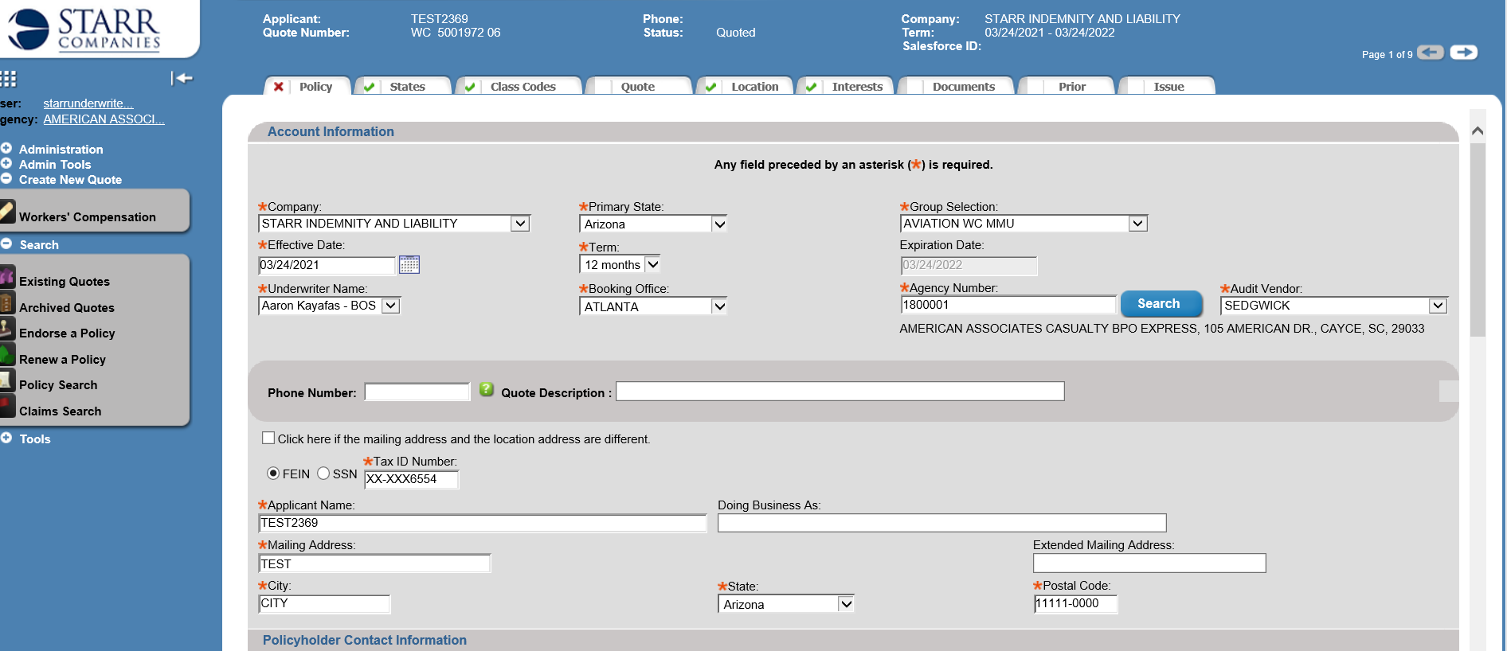

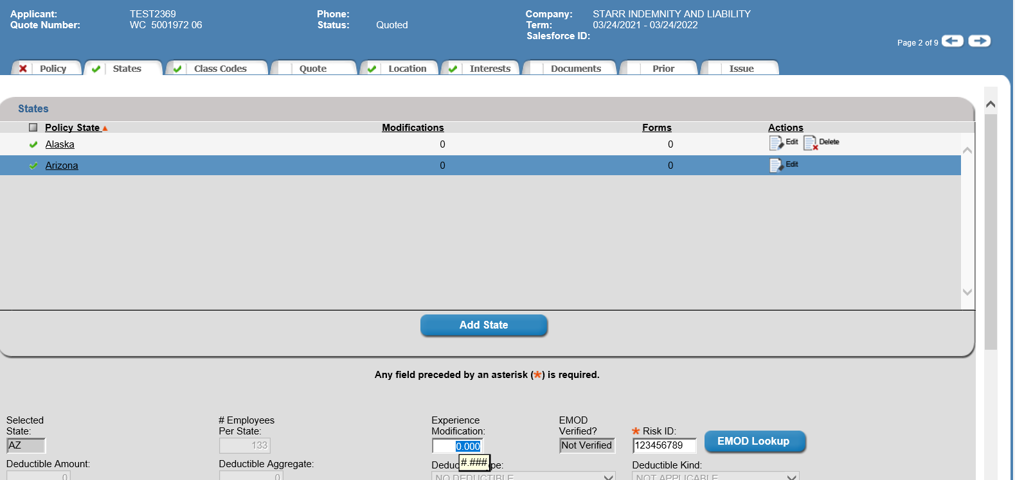

Add 2 location for both state

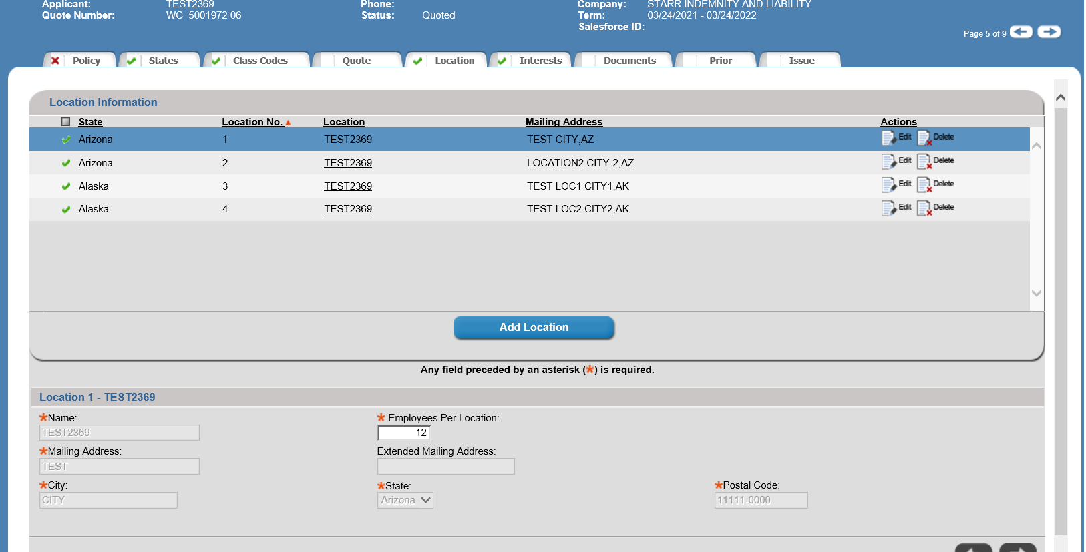

Loc2- AZ

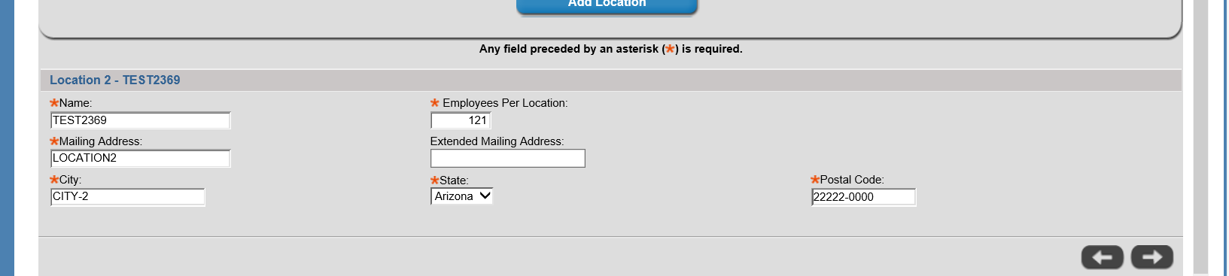

Loc1-AK

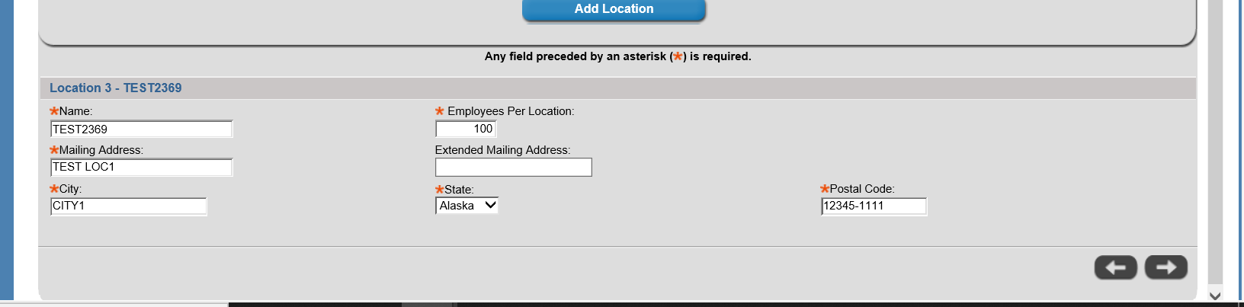

Loc2-AK

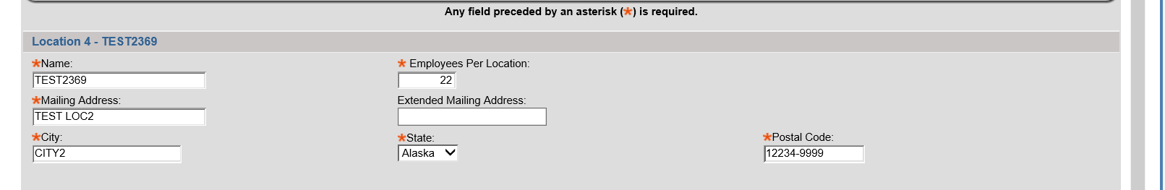

Add NI interest for first location for AZ

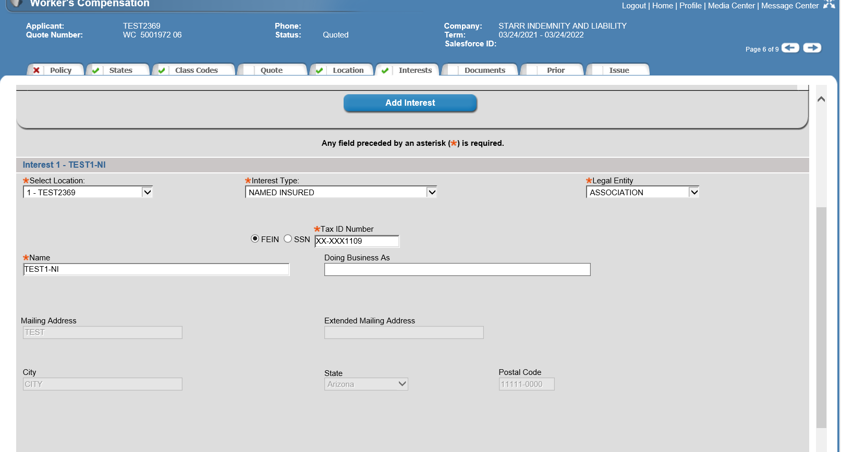

Add second NI interest for location1 -AZ

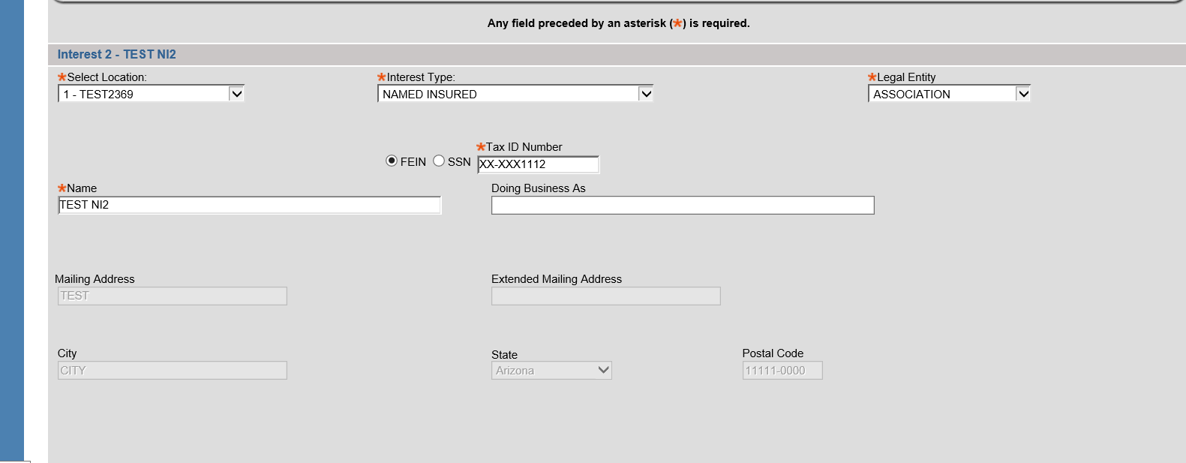

Add first NI for location2 -AZ

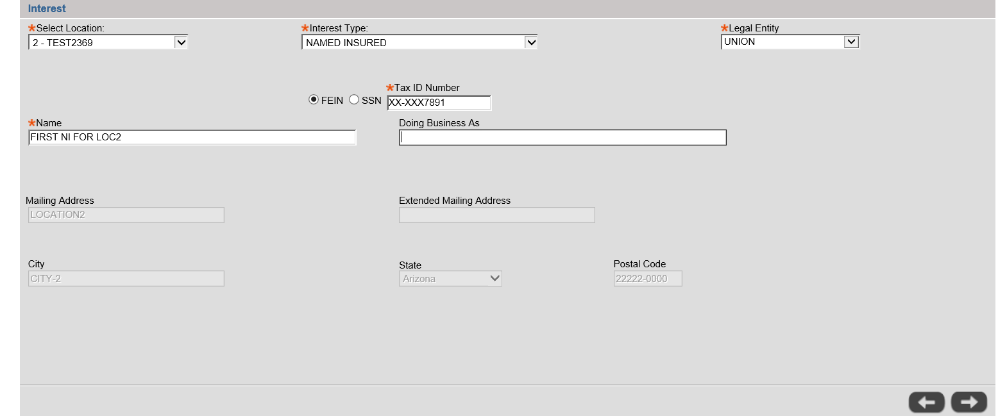

Second NI for location2-AZ

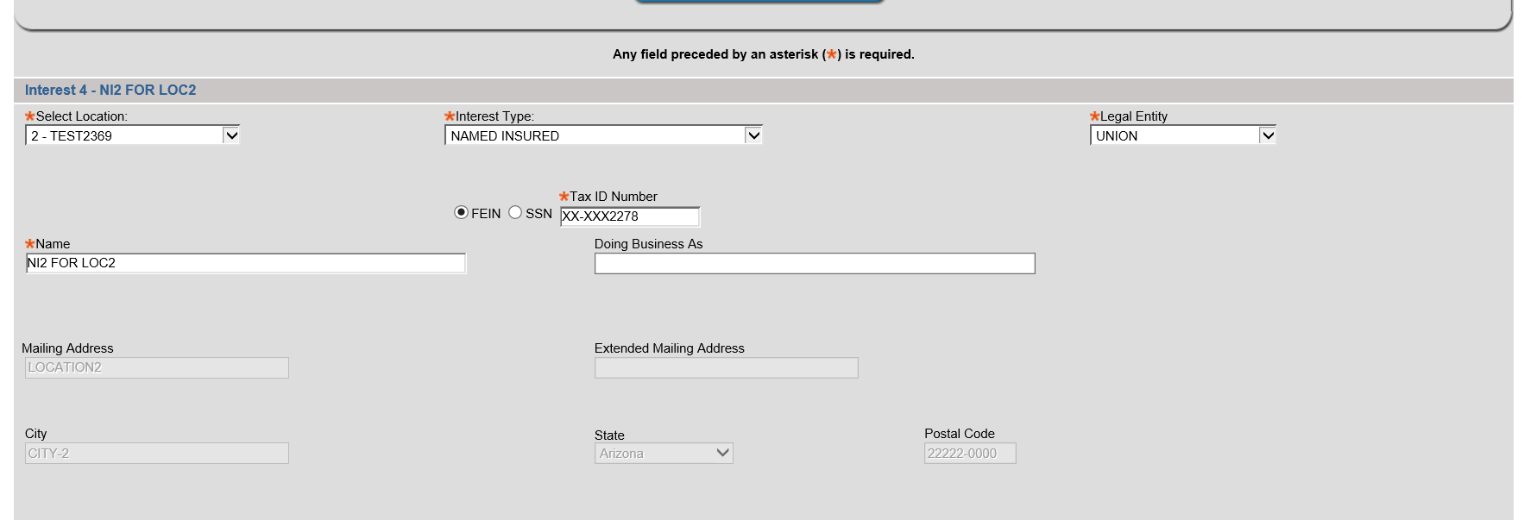

Rate the policy

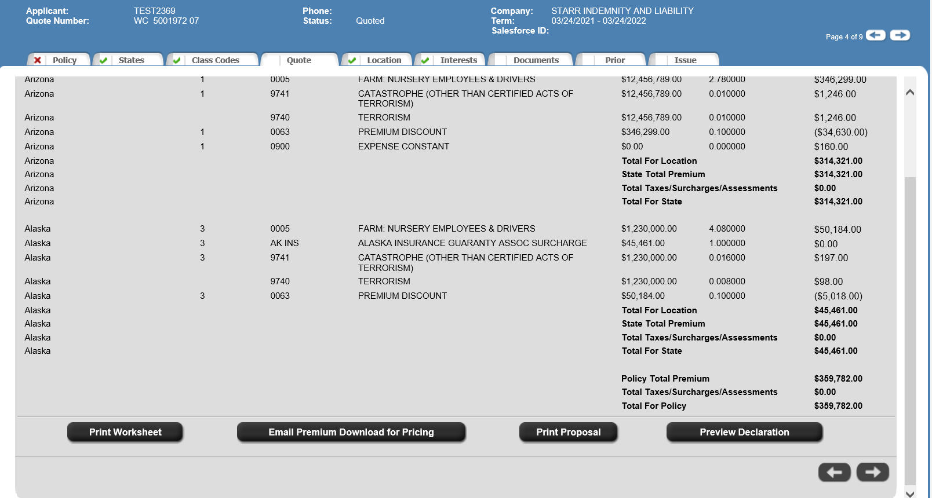

Preview Dec

[](sravs)

Named insured details mapping is not coming as expected way for the notices:

2) Add 1 DBA and 1 NI for both location for Az state

Quote# 5001977

NI1-

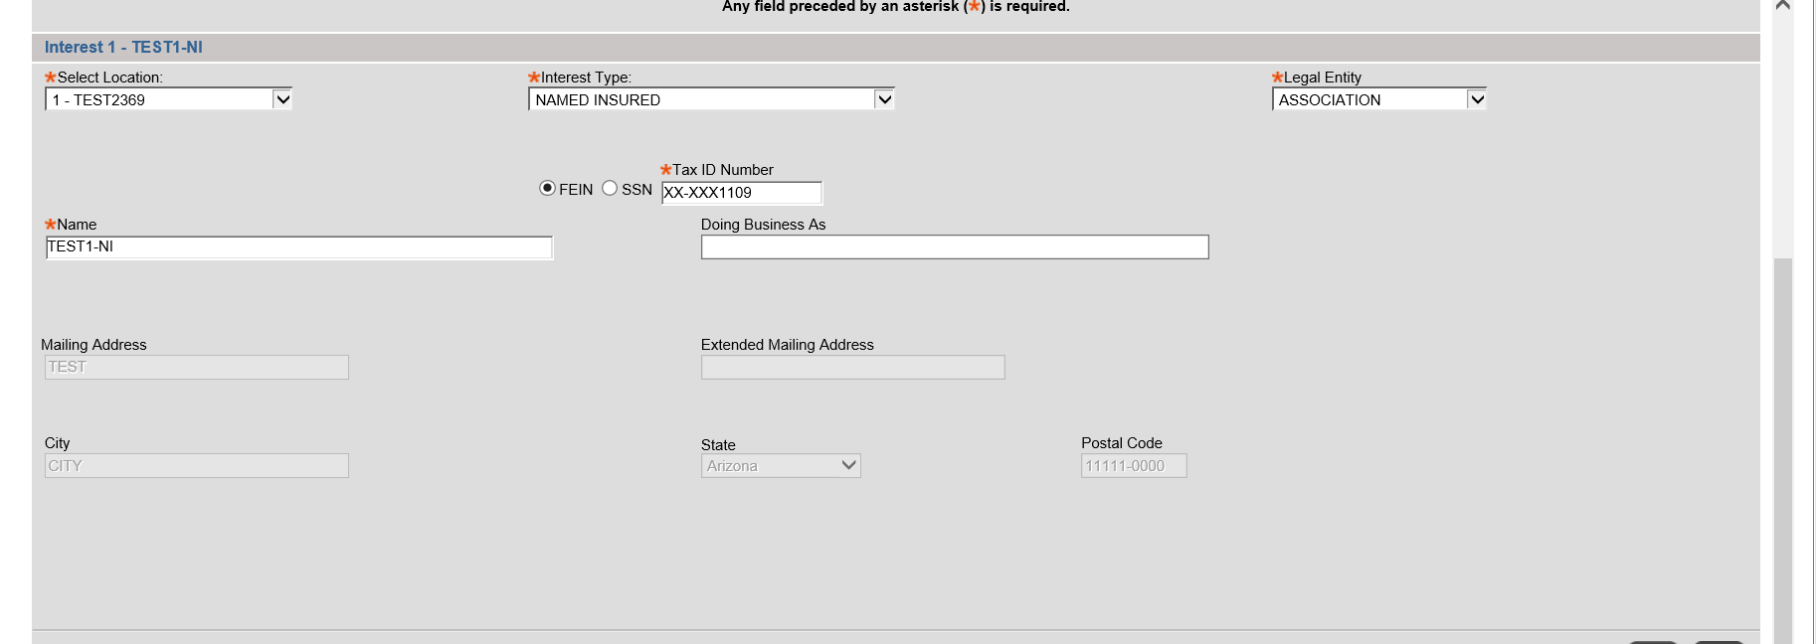

DBA-1

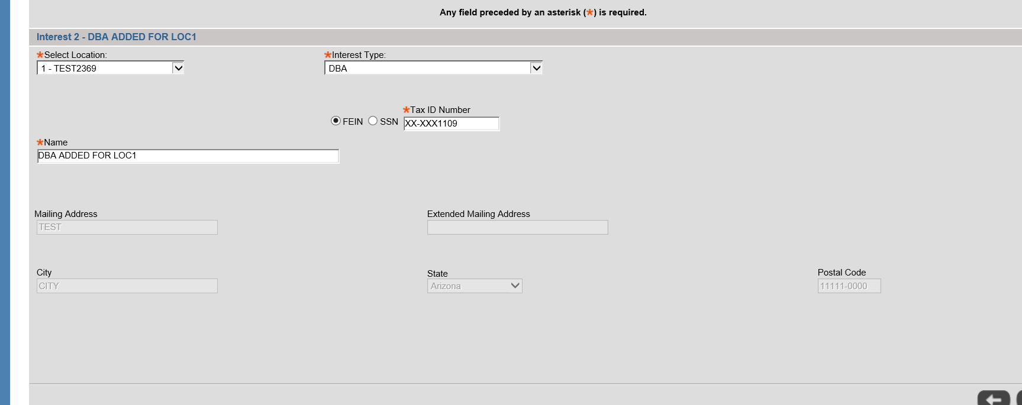

NI-1 for loc2

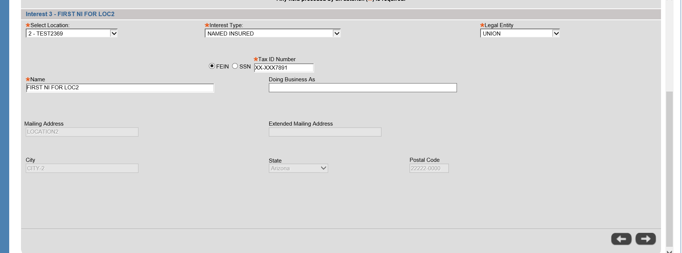

DBA for loc2

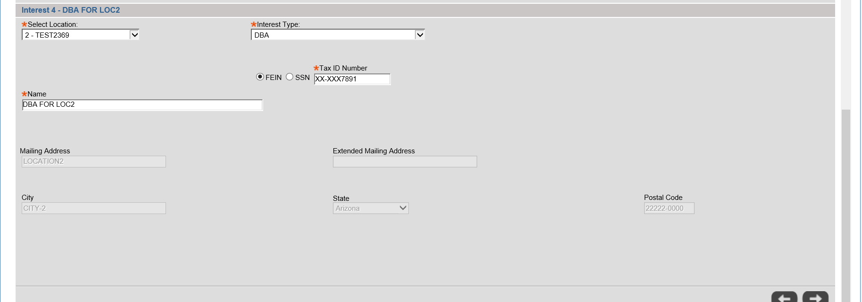

Rate and preview Dec



DBA and Named insured mapping are not coming proper for the Az notices.

Note: Mapping is not coming proper for other state notices too.